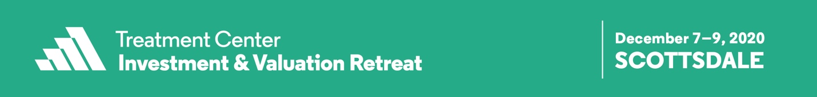

CALL FOR ABSTRACTS
FREQUENTLY ASKED QUESTIONS (FAQs)

- When/where is TCIV 2020?

The meeting will be December 7–9, 2020 at the Fairmont Scottsdale Princess in Scottsdale, Arizona

- What is the deadline for abstract submissions?
The deadline for submissions is Friday, March 28, 2020 at Midnight ET.

- How can I submit my abstract?
To submit a session abstract, please visit the submission website and create an account. Follow the instructions and be sure to fill out all required fields.

- May I include a table with my abstract?
No tables, figures, or images may be included in the abstract.

- How many presenters can be included in a session?
Abstract submissions can have a maximum of 2 presenters.

- Can I revise my abstract after it has been submitted?
You can log back into your account and make changes to your abstract until it enters the review process. Once your submission has been marked for review, you will not be able to make any changes.

- Is there an abstract submission fee?
There is no fee to submit an abstract for TCIV.

- When and how will I receive notification about the status of my abstract?
Notification regarding acceptance or denial of abstracts will be sent by email to the primary submitter by May 15, 2020.

- I have a question that isn’t answered above, who do I contact?
You may email Lauren Ero, Educational Programming Manager at lero@naccme.com with any additional questions. Please allow 2 business days for a response.

